**Title:** Nuisance species compromise carbon sequestration potential in an Eastern US temperate deciduous forest

**Authors:**

Luca L. Morreale1,2* ( Orcid ID: 0000-0003-2023-9150))

Rachel M. Hoffman1

Krystal J. Bagnaschi1

Iris A. Kennedy1

Erin MacMonigle1

Caroline Troy1

Cameron Dow1,3

Erika Gonzalez-Akre1 ( Orcid ID : 0000-0001-8305-6672)

Valentine Herrmann1 ( Orcid ID : 0000-0002-4519-481X)

Jennifer Jordan1,4 ( Orcid ID : 0000-0001-5521-360X)

Lukas Magee1,5

David Mitre2

Christopher Pate1

Jessica Shue6

Norman A. Bourg1

William J. McShea1 ( Orcid ID : 0000-0002-8102-0200)

Kristina J. Anderson-Teixeira1,2 ( Orcid ID : 0000-0001-8461-9713)

**Author Affiliations:**

1. Conservation Ecology Center, Smithsonian’s National Zoo & Conservation Biology Institute, Front Royal, Virginia 22630, USA
2. Forest Global Earth Observatory, Smithsonian Tropical Research Institute, Apartado Postal 0843-03092, Panama City, Panama
3. Department of Biology, West Virginia University, Morgantown, West Virginia 26506, USA
4. Department of Environmental Science and Public Policy, George Mason University, Fairfax, Virginia 22030, USA
5. School of Forest, Fisheries and Geomatics Sciences, University of Florida, Gainesville, Florida 32603, USA
6. Forest Global Earth Observatory, Smithsonian Environmental Research Center, Edgewater, Maryland 21037, USA

*corresponding author: [MorrealeLL@si.edu](mailto:MorrealeLL@si.edu);

**Running head:**

# Summary

* The future of the critical temperate forest carbon (C) sink is contingent on the role of nuisance species, including non-indigenous pests and pathogens and deer, yet their net effect on current and future C cycling is little understood. Here, we use 15 years of census data from a 25.6-ha plot in a Mid-Atlantic temperate forest to understand how nuisance species are affecting C sequestration.
* We analyzed biomass change and regenerative capacity in varying sections of the plot classified by deer browsing pressure and the abundance of species vulnerable to non-indigenous pests and pathogens.
* Biomass mortality increased, driving a net reduction in aboveground C storage, particularly in areas where canopy trees were vulnerable to non-indigenous pests and pathogens. There was also severe depletion of canopy tree species in the understory in areas with high deer browsing, endangering future canopy regeneration.
* Under current trends this forest will continue to lose living biomass and be in danger of a critical transition to a lower biomass ecosystem. The C sequestration of Eastern US deciduous forests is therefore likely overestimated in current global carbon models, and these forests could even transition to a net source of C in the future.

**Keywords**:

Pests and pathogens; temperate forests; carbon sequestration; white-tailed deer; ecosystem processes; invasive species

# 1 Introduction

The temperate forest biome plays a critical role in the global carbon cycle (C), accounting for almost half of the net global forest C sink (Harris *et al.*, 2021), and temperate deciduous forests alone sequester >300 Tg C yr-1 (Pugh *et al.*, 2019). Although it is currently a net C sink, the future of the temperate forest biome remains uncertain. The dominant pattern projected by Earth System Models is a continued, albeit weakening, temperate forest C sink for the remainder of the 21st century (Ahlström *et al.*, 2012; Wu *et al.*, 2023). Yet, global C models predict a wide range of future trajectories of carbon dioxide (CO2) sequestration (Ahlström *et al.*, 2012; Arora *et al.*, 2020), and current global C models do not represent certain influential mechanisms (*e.g.*, Fatichi *et al.*, 2014; Clark *et al.*, 2021). For instance, the impact of nuisance species, is not represented in global C - i.e., the impact of indigenous or non-indigenous species that, as a result of human influence, have much greater abundance in an ecosystem than they did historically, leading to detrimental ecological consequences (Nuñez *et al.*, 2010; Skandrani *et al.*, 2014). The impact of nuisance species on forest C budgets is also not considered in machine learning or niche models that seek to project future forest distribution and C stocks, nor is it in C offset projects (Wu *et al.*, 2023). Nuisance species, including non-indigenous insect pests and pathogens and over-abundant herbivores, are dramatically impacting carbon cycling in temperate deciduous forests around the world, and failure to account for them significantly limits understanding of future forest health and C sequestration potential.

Non-indigenous pests and pathogens can have a protracted impact on forests, often modifying forest productivity, nutrient cycling and successional trajectories (Herms & McCullough, 2014; Lovett *et al.*, 2016). Historically introduced to new ecosystems through intercontinental trade, non-indigenous forest insects and diseases will continue to proliferate with increased globalization and human movement (Brockerhoff *et al.*, 2006; Aukema *et al.*, 2010; Fischer *et al.*, 2013). Many of the prominent pests and pathogens in temperate deciduous forests have dramatic effects on canopy composition and structure, decimating once-abundant canopy species (Aukema *et al.*, 2010; Klooster *et al.*, 2014; Ellison *et al.*, 2018; Anderson-Teixeira *et al.*, 2021). Since many pests and pathogens do not currently occupy the full extent of their host species range, a significant portion of the remaining forest canopy is susceptible to future invasion by other nuisance species (Fei *et al.*, 2019).

Mammals whose population densities have been inflated due to human activities are also considered nuisance species (Clout & Russell, 2008; Murphy *et al.*, 2014), and in United States (US) eastern deciduous forests, this includes white-tailed deer (*Odocoileus virginianus*). Their populations have dramatically increased in the past 50 years (McShea *et al.*, 2003), due in large part to global change (Brown *et al.*, 2000; Rooney, 2001; Côté *et al.*, 2004). White-tailed deer preferentially browse on woody plant species in the seedling and sapling life stages, which reduces woody plant survival, growth and density (**mcgarvey_effects_2013a?**). Chronic white-tailed deer overabundance can reduce understory plant diversity and decrease the abundance of traditionally dominant woody species (*e.g.*, oak, *Quercus* spp.; (Habeck & Schultz, 2015; **bugalho_effects_2013a?**) while giving an advantage to species they find less palatable, including both indigenous (*e.g.*, pawpaw, *Asimina tribola*; spicebush, *Lindera benzoin*) and non-indigenous (*e.g.*, garlic mustard, *Alliaria petiolata*) species (Averill *et al.* (2017)). The strong impact of deer browsing, exacerbated by competition with dense deer-resistant understory vegetation and possibly climate change, results in dramatic reduction of canopy tree species in the understory (Russell *et al.*, 2017; Miller & McGill, 2019; Gorchov *et al.*, 2021; Miller *et al.*, 2023; **mcgarvey_effects_2013a?**).

Increased canopy tree mortality in combination with reduced canopy species recruitment in the understory is likely to have profound impacts on the deciduous forests of eastern North America. When global change pressures (*e.g.*, climate change, nuisance species) inhibit recruitment of canopy species, the stage is set for disturbances to push forest ecosystems over a tipping point, after which there is little chance that a forest will recover to its pre-disturbance state in the foreseeable future (Anderson-Teixeira *et al.*, 2013; McDowell *et al.*, 2020; **turner_novel_2023a?**). In the mid-Atlantic region of the eastern US, forests face a severe regeneration debt: there are insufficient juveniles of canopy tree species to replace the mature cohort of that species when they eventually die (Miller & McGill, 2019; Miller *et al.*, 2023). The juvenile canopy trees that are most common in contemporary mid-Atlantic forests represent a more mesophytic set of species (e.g., maple, *Acer* spp.; American beech, *Fagus grandifolia*) than historically dominated much of the region (e.g., oak, *Quercus* spp.; hickory, *Carya* spp.; (Thompson *et al.*, 2013; Nowacki & Abrams, 2015), but even these species associated with mesic conditions are often not present in sufficient abundance to replace the current canopy (Miller & McGill, 2019).

Understanding the combined effects of multiple nuisance species on forest ecosystem processes requires data on both the forest canopy and understory over an extended time. Here, we use 15 years of detailed tree census data from a large forest dynamics plot in the mid-Atlantic region of the eastern US to understand the effects of non-indigenous pests and pathogens and white-tailed deer on the forest C balance and regeneration potential. We test the following hypotheses: (1) canopy tree mortality and associated woody biomass loss are increasing, in large part due to non-indigenous nuisance species, (2) biomass gains from tree growth and recruitment have not kept pace with tree mortality, resulting in a decline in aboveground living biomass (-∆AGB), and (3) deer browsing has decimated the abundance of canopy tree saplings, suggesting that future tree mortality will result in substantial net biomass loss and sustained decrease in the C storage potential of this ecosystem.

# 2 Materials and Methods

## 2.1 Site Description

The study was conducted in the 25.6-hectare Forest Dynamics plot at the Smithsonian’s National Zoo and Conservation Biology Institute (SCBI) in Front Royal, Virginia (38 $​^{∘}$ 53’ 36.6’‘N, 78 $​^{∘}$ 08’ 43.4’’W). The forest dynamics plot, which is located in the central Appalachian Mountains adjacent to Shenandoah National Park, is composed of mature secondary eastern deciduous forest. As part of the Appalachian Oak forest region, the canopy is dominated by tulip poplar (*Liriodendron tulipifera*), oak (*Quercus* spp.), and hickory (*Carya* spp.) and the understory is primarily composed of spicebush (*Lindera benzoin*), paw-paw (*Asimina triloba*), American hornbeam (*Carpinus caroliniana*), and witch hazel (*Hamamelis virginiana*). The land-use history of the site is varied, including periods of agricultural development and intensive logging, with dendrological data estimating canopy tree establishment around 1900 (**mcgarvey_effects_2013a?**). The plot, which includes a four-hectare deer exclosure that has decreased the presence of deer since 1990, is divided into 640 quadrats, each measuring 20 x 20 meters. It is one of 78 sites in the Forest Global Earth Observatory (ForestGEO), a global network of forest dynamic plots that facilitates comparative forest ecology studies around the world (Anderson-Teixeira *et al.*, 2015; Davies *et al.*, 2021).

In addition to our consideration of the entire forest plot, we focus further on three upland forest portions of the plot (i.e., excluding low-lying areas around streams), with varying levels of exposure to non-indigenous insects and pathogens and white-tailed deer (Fig. 1). The first focal area we define as “low deer, low canopy vulnerability”: a 4-ha portion of upland forest in the SE quarter of the plot (Fig. **1a**), fenced in 1990 and maintained with only occasional deer presence over the past 24 years. This portion has a low abundance of canopy species vulnerable to non-indigenous pests and pathogens (Holm *et al.*, 2013). The second portion is “high deer, low canopy vulnerability”: 16.3 ha of upland forest area outside the deer exclosure with low abundance of canopy species affected by non-indigenous pests and pathogens (Fig. **1b**). The third focal area of the plot is “high deer, high canopy vulnerability”: corresponding to 2.2 ha of upland forest outside the deer exclosure with high abundance of canopy species affected by non-indigenous pests and pathogens. We defined upland forest according to topographic wetness index, which was calculated for the forest plot by McGregor *et al.* (2021). We defined vulnerability to non-indigenous insects and pathogens based on the abundance (>20% of tree basal area) of canopy species affected by non-indigenous pests and pathogens at the time of plot establishment in 2008. The following canopy species were identified as vulnerable: ash (*Fraxinus* spp.), elm (*Ulmus* spp.), butternut (*Juglans cinerea*), and American chestnut (*Castanea dentata*) (Anderson-Teixeira *et al.*, 2021).

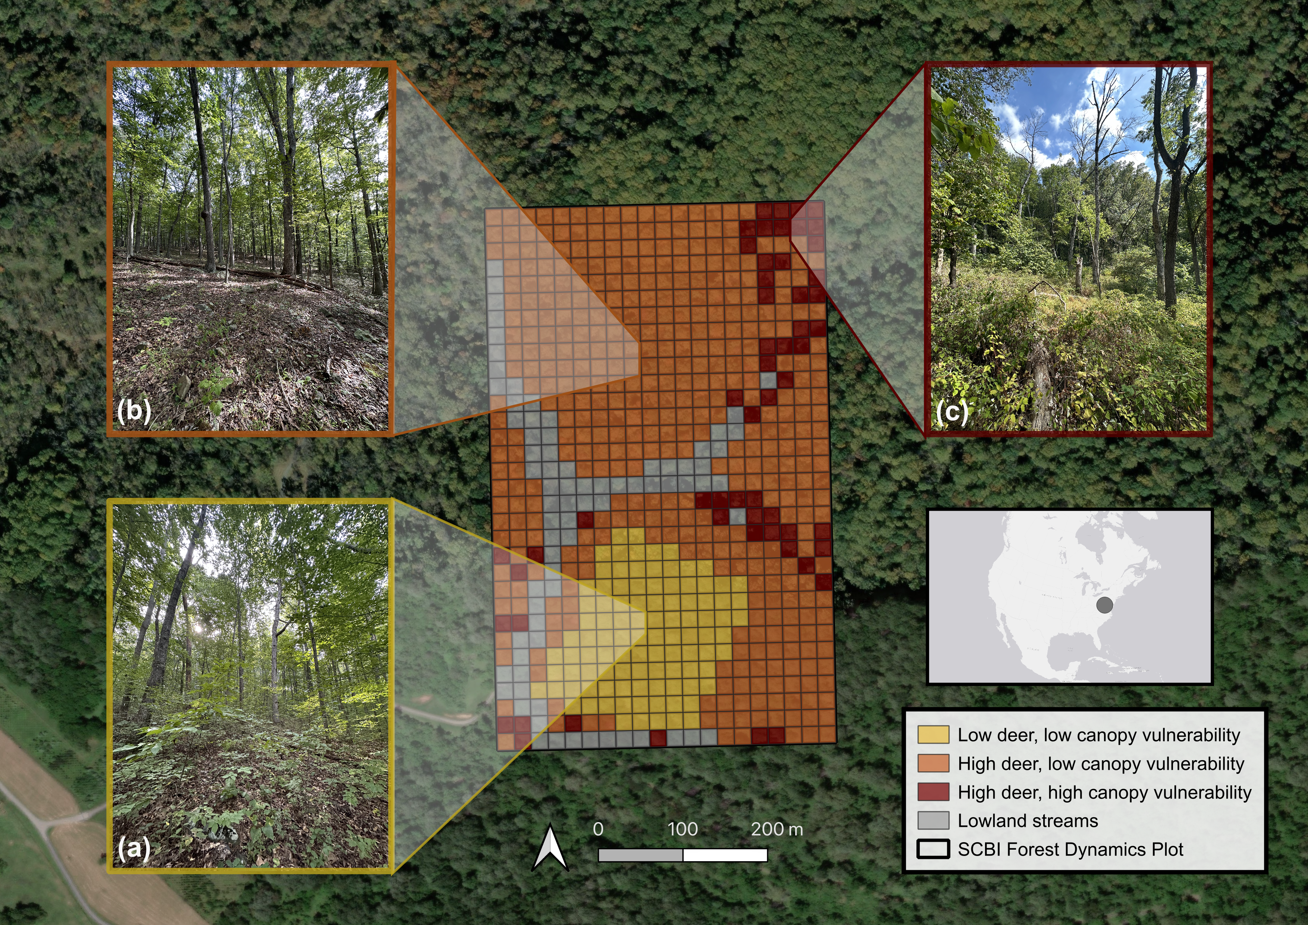

***Figure 1. Map and photos of the Forest Global Earth Observatory (ForestGEO) plot at the Smithsonian’s Conservation Biology Institute (SCBI) in Virginia, USA.*** Our analysis focuses on three portions of the plot: (a) low deer density, low abundance of canopy trees vulnerable to non-indigenous insects & pathogens, (b) high deer density, low abundance of canopy trees vulnerable to non-indigenous insects & pathogens, and (c) high deer density, high abundance of canopy trees vulnerable to non-indigenous insects & pathogens. *All photos taken September 2023 by K. Anderson-Teixeira; aerial photography from ESRI World Imagery*.

## 2.2 Data collection

As part of the ForestGEO network, the plot undergoes a comprehensive woody plant inventory every five years following the protocol detailed in Condit (1998). This inventory, hereafter referred to as the census, includes all stems greater than one centimeter in diameter at breast height (1.3 meters; dbh). The census records the dbh, species, living status, and spatial location of each censused stem. Each individual is marked with an identifying number for sequential data collection in subsequent censuses. In multi-stemmed individuals, each additional stem that surpasses the dbh threshold receives a stem number and associated tag. The plot was established in 2008 and recensused three times since (2013, 2018, 2023), providing 15 years of forest dynamics data. In the last census, systematic data cleaning was continuously implemented 1) in an ESRI ArcGIS Field Maps application via built-in checks and 2) on a daily basis, via error reports generated through GitHub actions (Kim *et al.*, 2022). Each stem’s location was recorded in the Field Maps application using a digitized map of the plot. In addition to the ForestGEO census, a tree health and mortality survey has been conducted annually starting in 2014 on all trees with a dbh ≥ 10 cm in the previous census (Gonzalez-Akre *et al.*, 2016). Data were collected on the current status, canopy position, percentage of living and intact crown, and visible indicators of tree health, (*e.g.* physical damage, potential pathogens, insect infestation).

## 2.3 Calculating biomass dynamics and stem recruitment

We estimated total aboveground biomass (AGB) from the dbh of each stem in each census using extra-tropical allometric equations from the R package *allodb* (Gonzalez-Akre *et al.*, 2022). The *allodb* package creates species-specific allometric equations by weighting all applicable allometries within its database filtered by tree size, geography, and taxonomic information. Using the calculated stem AGB, we estimated AGB stocks at each census year for each of the plot regions, as well as the entire 25.6-ha plot. We quantified trends in AGB over time by calculating annualized AGB fluxes including: 1) the net change in AGB, 2) aboveground woody growth (AWG; the addition of woody biomass from tree growth), 3) aboveground woody mortality (AWM; the change of living biomass to necromass due to tree mortality), and 4) aboveground woody recruitment (AWR; the addition of living biomass through recruitment) for each census interval and plot region. We further assessed the role of nuisance species on mortality by calculating AWM flux for each year and each species using the annual mortality survey data (excluding stems < 10 cm dbh).

In addition to the estimation of AWR biomass flux, we analyzed the possible effects of nuisance species on recruitment based on counts of newly recruited stems. We categorized each species as either canopy or understory based on expert knowledge of life history traits. *Quercus* spp. and *Carya* spp. were grouped by genera to better assess differences between the recruitment of canopy and understory species. We then calculated the number of new stems for each census interval for each species or genera. Finally, we assessed the spatial overlap of biomass loss and recruitment of canopy species. We calculated the ∆AGB of canopy trees within each 0.4 hectare quadrat between 2008 and 2023 and the AGB of canopy species in the understory in 2023.

# 3 Results

Consistent with hypothesis 1, all sections of the plot experienced increased mortality (AWM) since plot establishment in 2008 (Figure 2b). The largest increases in mortality occurred in areas with the highest vulnerability to non-indigenous pests and pathogens. Initially, plot-level AWM remained constant, maintaining rates of 1.5 and 1.4 Mg C ha-1 yr-1 in the first two census intervals. However, in the most recent period from 2018 to 2023, AWM increased to 3 Mg C ha-1 yr-1. Despite initial uniformity in AWM across all plot regions, high canopy vulnerability areas experienced substantial increases in AWM across all censuses, resulting in a three-fold increase in AWM from the first to most recent interval. Low canopy vulnerability regions displayed smaller rises in AWM and only in the final survey period.

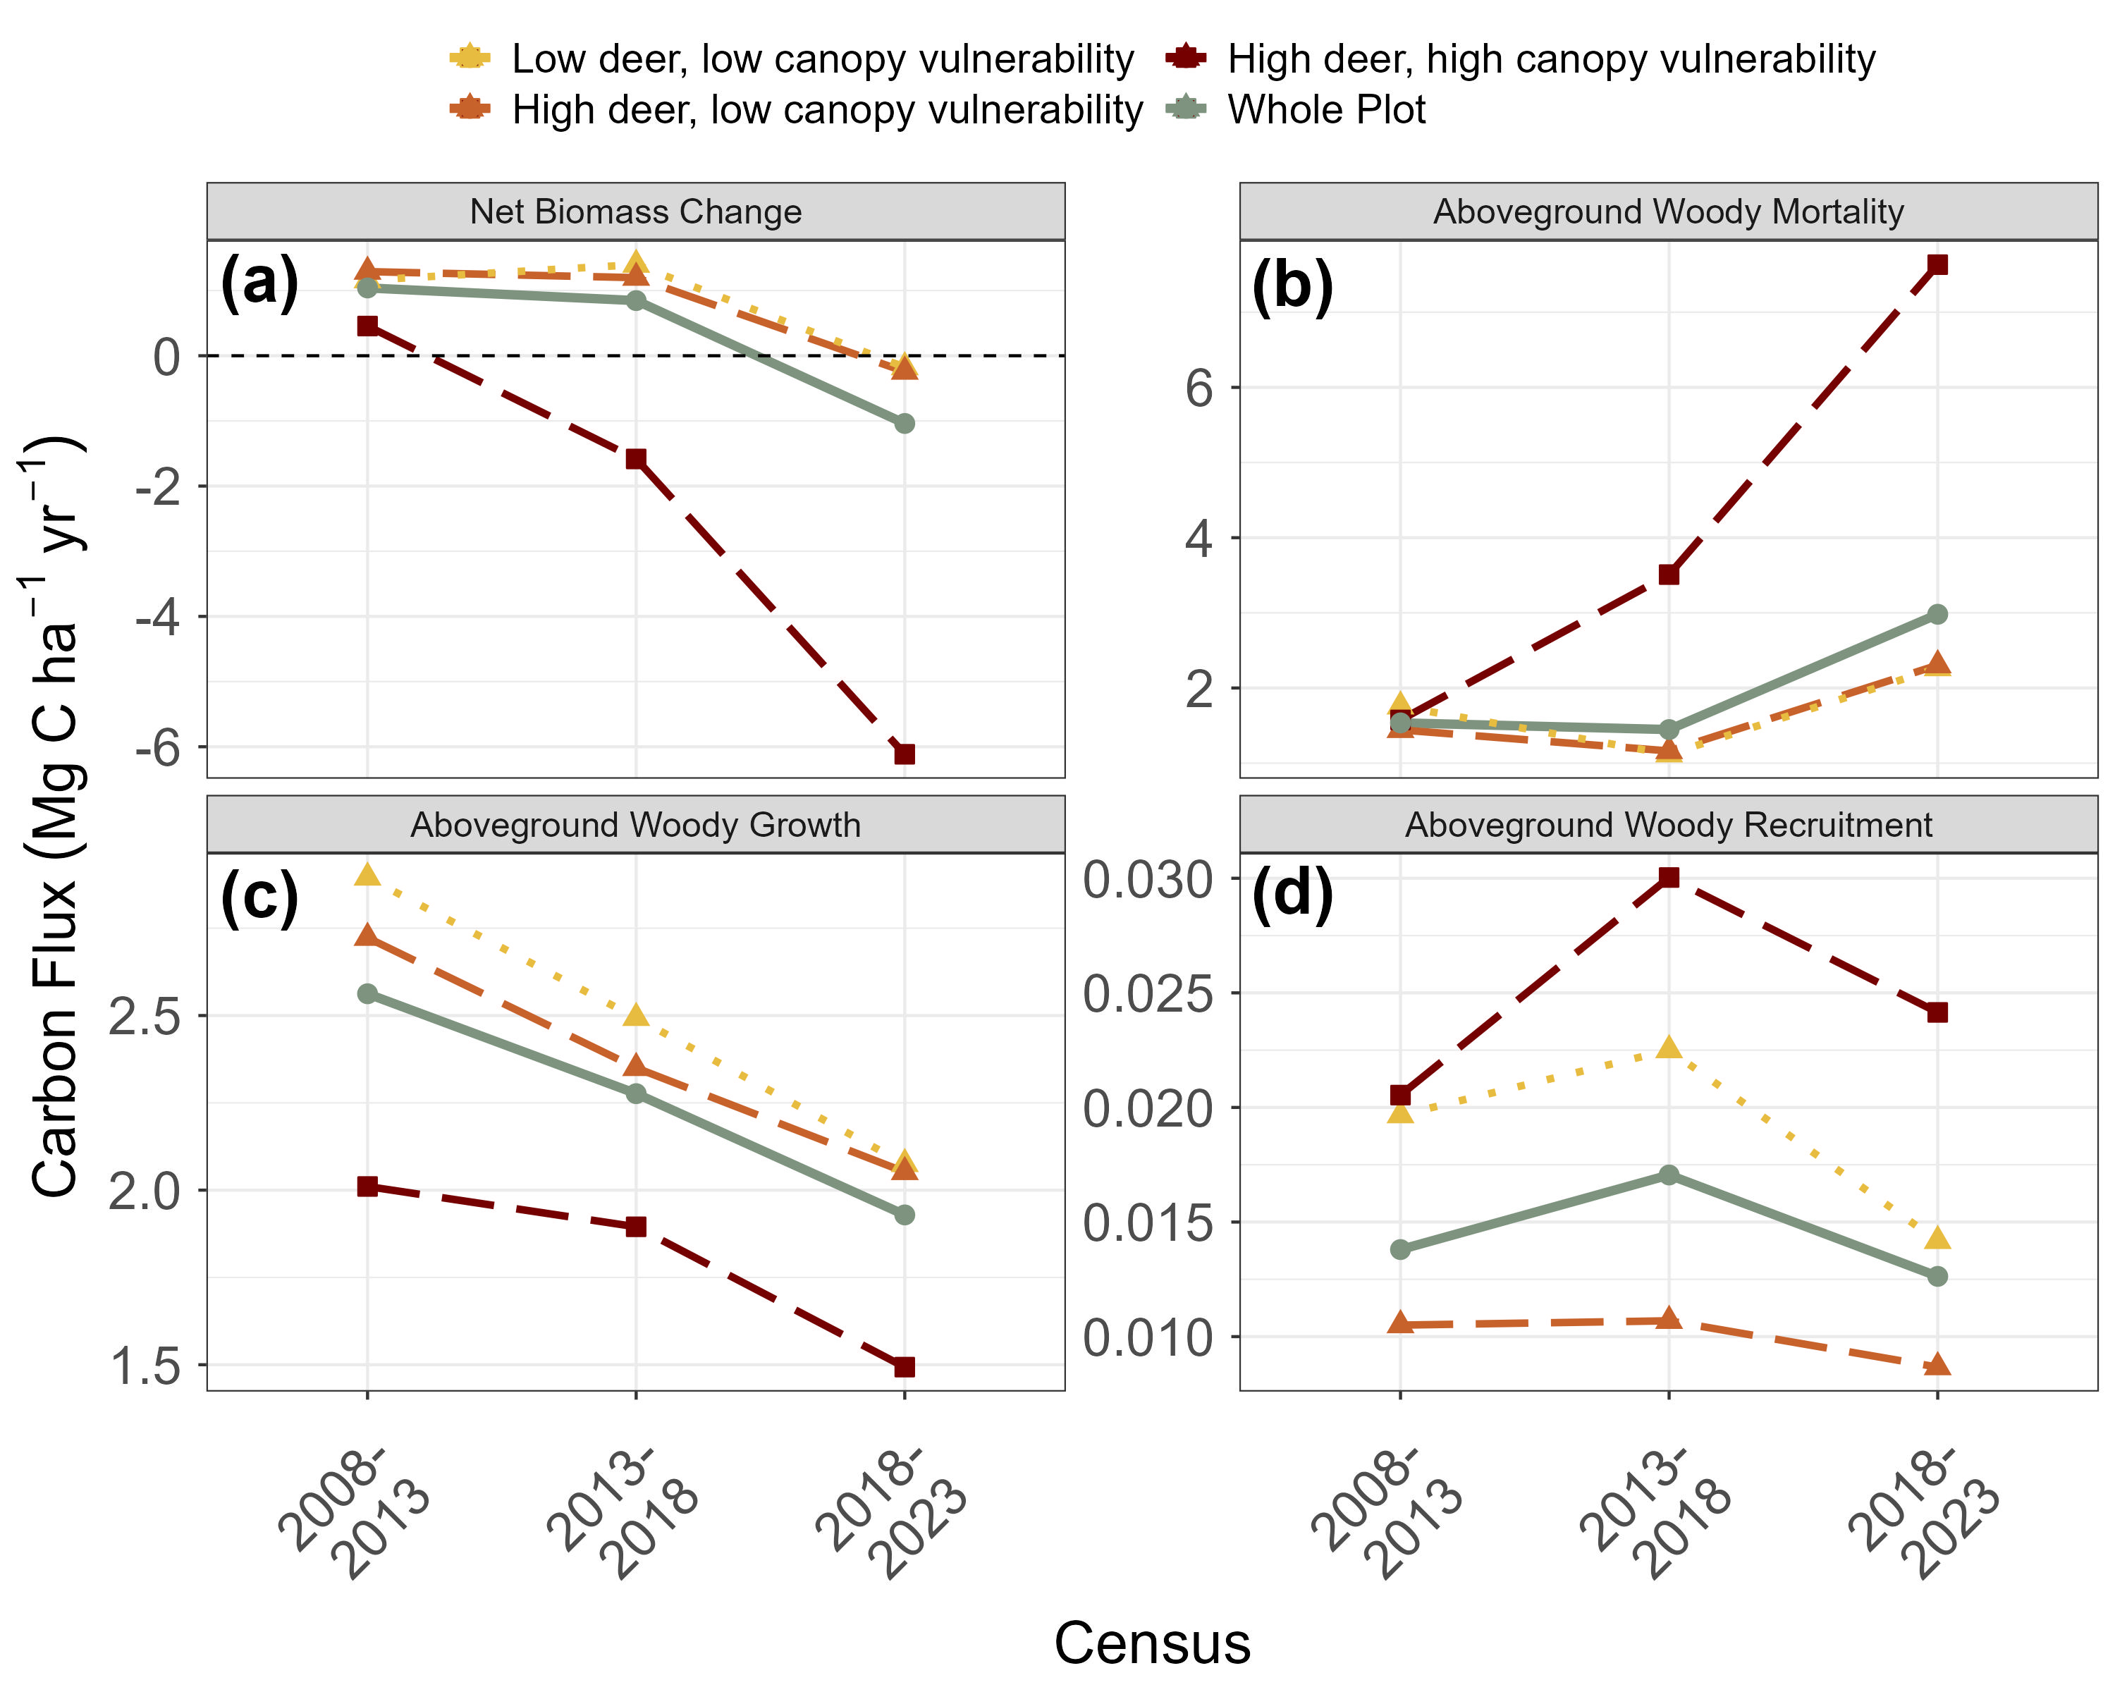

***Figure 2. Changes in aboveground woody biomass at the SCBI ForestGEO plot over each census interval since 2008 establishment, including (a) net change, (b) losses to mortality, and gains from (c) woody productivity and (d) recruitment.*** Values are shown for the plot as a whole and for regions differentiated by intensity of deer browsing and 2008 abundance of canopy tree species vulnerable to non-indigenous pests and pathogens.

Though AWM increased throughout the plot AWM rates remained stable in a majority of individual species. The increasing trend of AWM was driven primarily by two species: white ash (*Fraxinus americana*) and black oak(*Quercus velutina*) (Figure 3). *Fraxinus americana*, the host species for non-indigenous pest emerald ash borer (*Agrilus planipennis*), had the highest annual AWM of any species present on the plot, with an average flux of 1.5 Mg C ha-1 yr-1 and loss peaking at 5.3 Mg C ha-1 yr-1 in 2020. *Quercus velutina* experienced the second-highest rate of AWM at a rate of 0.9 Mg C ha-1 yr-1. The average annual AWM of these two species (2.5 Mg C ha-1 yr-1), was higher than that of all other species combined (1.2 Mg C ha-1 yr-1). Moreover, both species exhibited significant increases in AWM since the start of the census, a trend also observed in three other species in the Oak genera—*Quercus rubra*, *Quercus prinus* and *Quercus alba*.

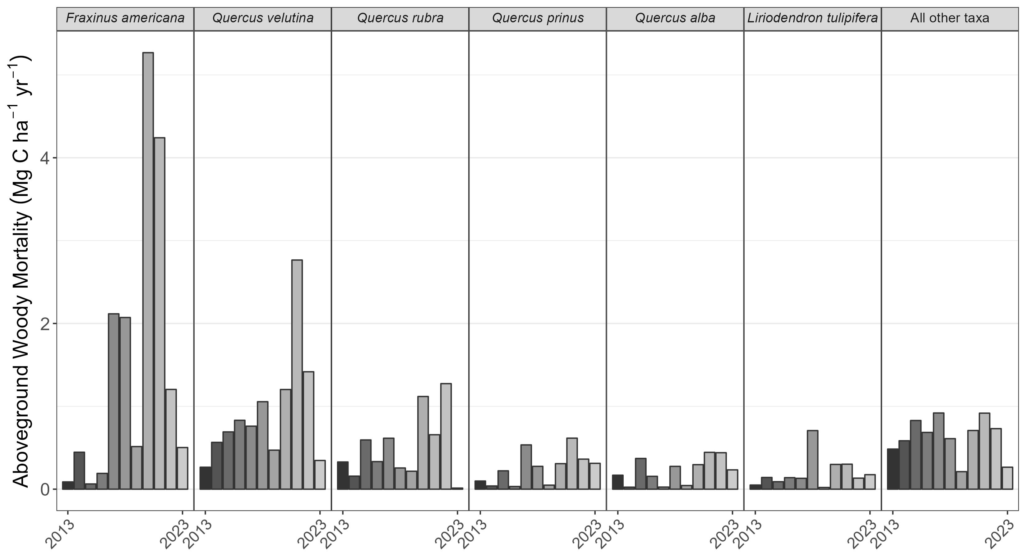

***Figure 3. Annual woody mortality by species at the SCBI ForestGEO plot from 2008-2023.*** Shown are the six canopy taxa with highest average mortality rate in descending order and a category including all others. The census included all stems ≥ 10 cm in the most recent full census.

Consistent with hypothesis 2, biomass losses to mortality outpaced biomass gains from tree growth over the 2018-23 census interval (Figure 2a). For the first time since establishment of the SCBI ForestGEO plot, living aboveground C stocks (AGB) decreased between 2018 and 2023 (Figure 4), declining from 145.9 to 140.9 Mg C ha-1. Prior to this period, AGB had consistently increased at a rate of 2.6 Mg C ha-1 yr -1 between 2008 and 2018 (Figure 2a). In regions characterized by high deer density and high canopy vulnerability, > 33% of AGB was lost over the past two censuses: dropping from 115.8 Mg C ha-1 in 2013 to 107.7 Mg C ha-1 in 2018 and then to 77 Mg C ha-1 in 2023. Conversely, areas with low density of vulnerable canopy species experienced marginal losses of AGB between 2018 and 2023; both inside and outside of the deer exclosure, biomass decreased from 154.3 to 153.3 Mg C ha-1 and 164.6 to 163.6 Mg C ha-1, respectively.

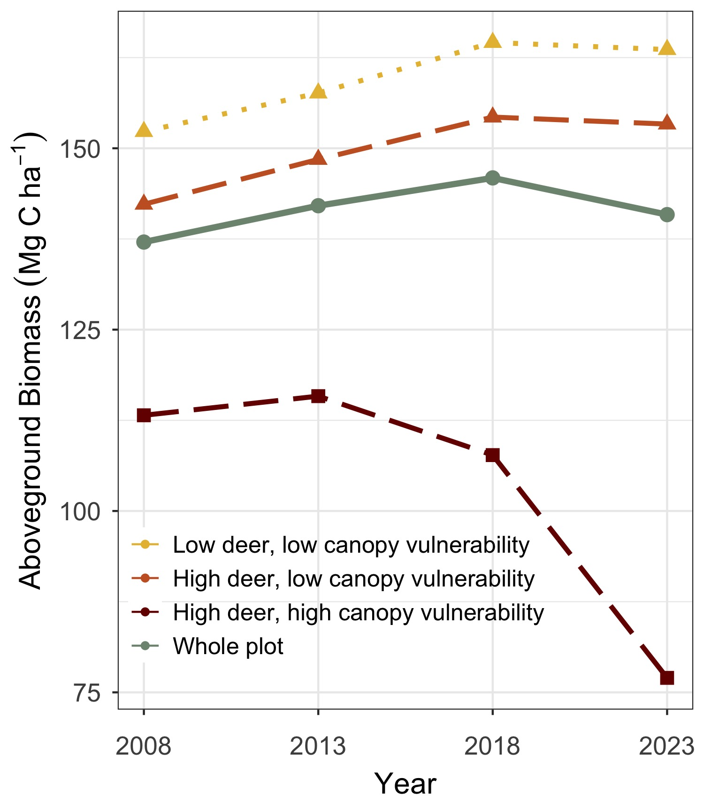

***Figure 4. Aboveground biomass at the SCBI ForestGEO plot since 2008 establishment.*** Values are shown for the plot as a whole and for regions differentiated by intensity of deer browsing and 2008 abundance of canopy tree species vulnerable to non-indigenous pests and pathogens.

Transition from net AGB accumulation to loss was not solely attributable to increased mortality; biomass accrual from woody growth (AWG) declined across all census intervals, even when AWM did not increase (Figure 2c). Plot-wide AWG decreased by -30 %, from 2.6 Mg C ha-1 yr-1 over 2008-2013 to 1.9 Mg C ha-1 yr-1 in the 2018-2023 interval. Areas with low canopy vulnerability consistently displayed the highest AWG (2.1 Mg C ha-1 yr-1 in the 2018-2023 period), while the AWG in the portion with high canopy vulnerability was significantly lower (1.5Mg C ha-1 yr-1). Woody recruitment flux (AWR), constituting a minor fraction of net biomass change, showed no significant temporal trend (Figure 2d). AWR consistently remained lowest in areas characterized by high deer density and low canopy vulnerability, whereas it reached its highest levels in regions with high canopy vulnerability, recording rates of 0.01 Mg C ha-1 yr-1 and 0.025 Mg C ha-1 yr-1, respectively.

Consistent with hypothesis 3, deer density had strong mediating effects on the composition of woody stem recruitment (Figure 5). The region characterized by low deer density exhibited significantly higher annual recruitment of canopy taxa compared to those areas with higher deer density— specifically, 38.7 stems ha-1 yr-1 compared to 19 ha-1 yr-1. In particular, the recruitment rate of *Carya* spp. and *Quercus* spp., late-successional taxa characteristic of this forest’s expected climax state, was reduced by > 50% in areas with high deer density. The prevalence of vulnerable canopy species in regions with low deer density showed no significant impact on the total quantity of canopy species recruitment into the understory. However, recruitment of *Fraxinus americana* and *Fagus grandifolia* was higher in areas with high canopy vulnerability, while recruitment of *Ulmus rubra* and *Carya* spp. was lower. Across all regions, the recruitment rate of understory taxa was nearly 10 times that of canopy taxa. Recruitment of *Lindera benzoin* was high across all regions (> 100 stems ha-1 yr-1), and significantly increased in areas with high deer densities while peaking in areas that also had low canopy vulnerability. *Asimina triloba* recruitment was also lowest within the deer exclosure (18.6 stems ha-1 yr-1) but was highest in the region with high deer density and high canopy vulnerability (76.6 stems ha-1 yr-1).

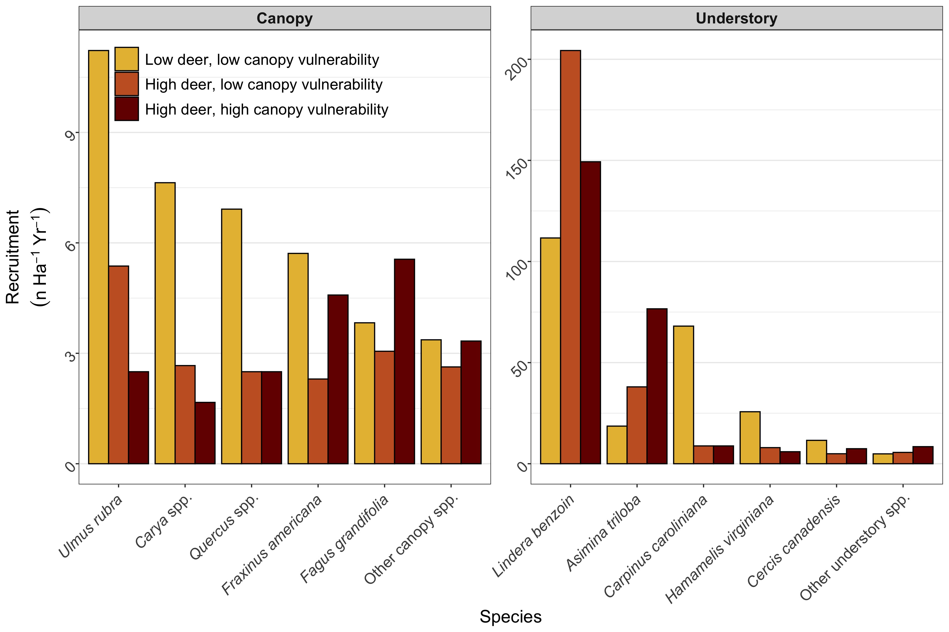

***Figure 5. Average annual recruitment (2008-2023) of canopy and understory tree species at the SCBI ForestGEO plot across areas differentiated by intensity of deer browsing and 2008 abundance of canopy tree species vulnerable to non-indigenous pests and pathogens.*** Note that y-axes differ, with understory species recruitment > 20 times that of canopy species recruitment.

There were significant areas of suppressed regeneration of canopy species, often coincident with decreasing AGB. Only 21.7% of the plot (mostly inside the deer exlosure) exhibited an understory with high AGB of species capable of reaching the canopy. Within the plot areas characterized by high deer density and high canopy vulnerability, 84% of the area had lost canopy biomass, only 5.4% had an understory containing high AGB of canopy taxa, and 0% of area exhibited both a healthy understory and increasing AGB. In contrast, 70.7% of the plot area with low deer density and low canopy vulnerability had high AGB of canopy species in the understory, indicating a higher likelihood of future C sequestration. Furthermore, 72.7% of the region with low deer density and low canopy vulnerability had a net increase of AGB.

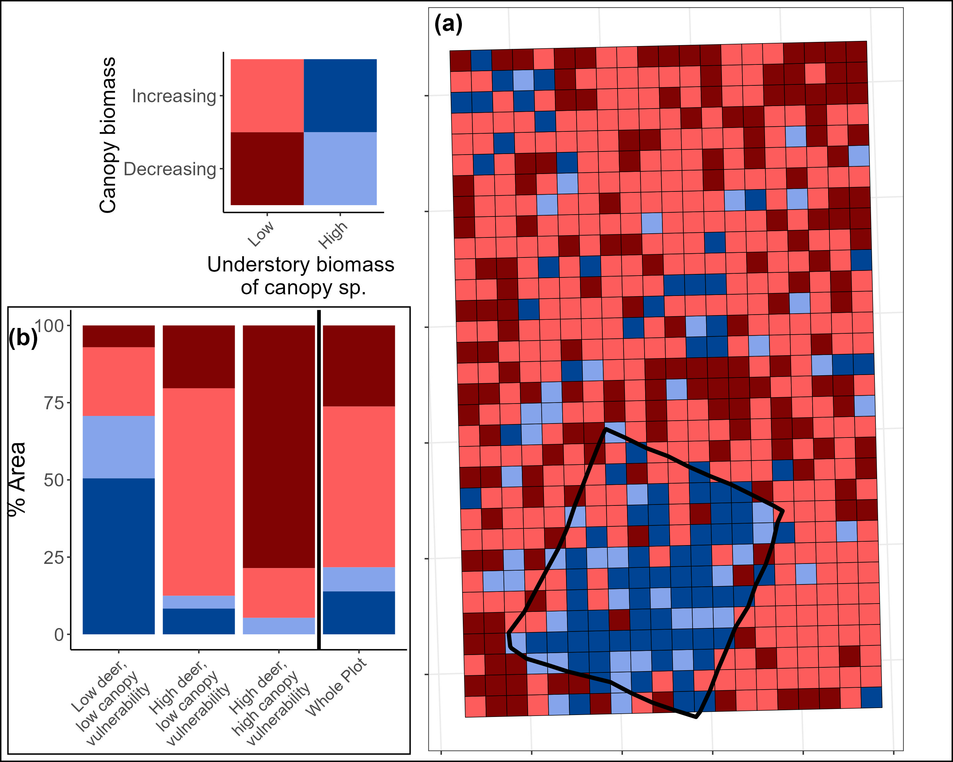

***Figure 6. Map of changes in canopy biomass (2008-2023) and the biomass of canopy taxa in the understory in 2023 within the SCBI ForestGEO plot.*** (a) Each .04 ha quadrat is classified by the ∆AGB of canopy trees over the 15-year study period and the AGB of canopy taxa in the understory in 2023. (b) The % area of each region that falls within each classification.

# 4 Discussion

Our results reveal that nuisance species have compromised biomass stocks and regenerative capacity at the SCBI ForestGEO plot, reducing the recent and future carbon sink of this forest. Canopy tree mortality and associated AWM increased, particularly in plot areas affected most heavily by non-indigenous insects and pathogens (hypothesis 1, Figs. 2- 3). These increases in AWM were not offset by biomass increases through AWP, which decreased, or recruitment, resulting in net biomass loss (hypothesis 2, Figs. 2, 4). This net AGB loss occurred despite localized increases in AGB across most of the plot, particularly in areas with low canopy vulnerability (Fig. 6). Recruitment of canopy tree species was low throughout the plot (Fig. 5), and there was low biomass of canopy species in the understory, particularly in areas with high deer density (Fig. 6). Moreover, low recruitment of canopy species in areas with high canopy vulnerability suggests that heavy deer browsing on canopy species may be exacerbated in areas with canopy openings due to nuisance-species driven mortality where fast-growing understory species that are resistant to deer can take advantage, further competing with canopy recruitment. Thus, nuisance species have severely compromised both recent and future carbon sequestration in this forest, contradicting models projecting increases in AGB (Wu *et al.*, 2023).

While nuisance species have had a large impact on AGB loss at our site, simultaneous changes including stand aging and climate change have also contributed to observed trends. The majority of AGB loss has occurred through increased EAB-driven mortality of *Fraxinus spp.* (Anderson-Teixeira *et al.*, 2021), yet mortality among oak species, which is not linked to a non-indigenous nuisance species, is substantial as well (Fig. 3). As is the case at our site, oak species in the region are generally found in older, relatively even aged cohorts, and this can contribute to accelerated mortality rates (Oak et al., 2016). However, large oak mortality events, which often occur over protracted periods of time, have been common globally over the past century and are often termed “oak decline” due to the complex abiotic and biotic factors which interact to incite mortality (Manion and Lachance, 1992). Oak decline is believed to be the result of climate-driven imbalances in carbohydrate dynamics, which weakens oak trees’ resistance to pest and pathogen invasion, eventually leading to mortality (Manion and Lachance, 1992). Similarly, stand aging and climate change may both have contributed to the observed decline in AWP (Fig. 2b), which in turn contributed to reduced AGB (Figs. 2, 4). Specifically, reductions in individual tree growth rates at this site are associated with increasing stem diameters, an aging stand, and rising summer temperatures (Anderson-Teixeira *et al.*, 2022; **dow_warm_2022?**). These complexities underscore the importance of multiple anthropogenic stressors, including but not limited to nuisance species, in shaping 21st century forest carbon dynamics.

Similarly, a complex chain of processes – from seed production to germination and seedling survival – affects sapling recruitment, and relying on the current understory as a proxy for future canopy presents challenges. Some canopy species, including some *Quercus* spp., are hypothesized to recruit in synchronized pulse events (Koenig, 2021). Moreover, white-tailed deer populations have varied greatly over the last century (Hanberry & Hanberry, 2020), and a decline in deer population that reduces browsing pressure and coincides with a recruitment pulse could allow for substantial, rapid regeneration of canopy species. However, current recruitment levels are below a rate which we would expect in maturing secondary forests. When overlaid with increasing mortality, regeneration is likely to be insufficient to prevent extended periods without a closed canopy.

The observed trends in AGB loss, including increasing AWM and decreasing AWP, will not necessarily be maintained as continuous directional trends in the future. The top driver of increasing AWM has been EAB-driven mortality of *Fraxinus spp.*, but *Fraxinus* AWM has started declining as most individuals ≥10 cm have already died (Fig. 3). It is possible that increasing AWM will be maintained by trends of increasing oak mortality or by other non-indigenous insects or pathogen, which have arrived in the region in multiple waves over the past century (Anderson-Teixeira *et al.*, 2021). The ongoing emergence of new threats endangers other important canopy species: beech leaf disease, a non-indigenous pathogen lethal to *Fagus grandifolia* and first detected in 2012, is rapidly spreading throughout eastern US deciduous forests (Reed *et al.*, 2022). Another non-indigenous pathogen, Sudden Oak Death, is currently confined to the Western US but is causing widespread mortality in multiple Oak species and poses huge risks if it were to successfully spread to this region (**conrad_threat_2020?**). Thus, we consider it likely that oak decline, additional non-indigenous insects or pathogen species, and climate stressors will continue to elevate tree mortality at this site in the coming decades. Similarly, the observed long-term declines at this site in AWP (Fig. 2b) and individual tree growth (Anderson-Teixeira *et al.*, 2022) remain poorly understood, hindering prediction of their future trends. Overall, there remains large uncertainty as to the future trend in AGB at this site, but our analysis makes it clear that these trends have been and will continue to be substantially impacted by nuisance species.

Despite inherent limitations in extrapolating findings into the future and from a single site to a broader region, we find robust evidence suggesting a broader applicability of our results. Mixed-hardwood forests, akin to our study site, are typical of the mid-Atlantic region. Furthermore, the widespread occurrence of vulnerable species (*e.g.* *Fraxinus* spp.) and continued spread of non-indigenous nuisance species (*e.g.* emerald ash borer, EAB) reinforces the relevance of our findings to the broader regional context. EAB consistently induces near-total mortality in *Fraxinus* spp. once infected, to such an extent that five species in North America (including *Fraxinus americana*) are now critically endangered (Knight et al, 2013, IUCN Red list). Similarly, temperate forests of eastern North America continue to be affected by a variety of non-indigenous pests and pathogens (Aukema *et al.*, 2010; Fei *et al.*, 2019; Anderson-Teixeira *et al.*, 2021), and emerging threats (e.g., beach leaf disease, sudden oak death) could also have profound impacts (Reed *et al.*, 2022; **conrad_threat_2020?**) on forests across the region. Also paralleling our site, persistently elevated deer populations are reported throughout eastern US forests, and pressures from deer brousing have contributed to regneration debts of canopy species throughout the region (Miller & McGill, 2019; Miller *et al.*, 2023).

Accounting for nuisance species in carbon models and future forest predictions is imperative. Our results underscore how ignoring nuisance species at our site, and likely much of the region, creates an expectation that temperate decidious forests will keep growing steadily and accumulating C (Wu *et al.*, 2023). Instead, by increasing tree mortality, nusicance species alter short-term C dynamics and result in large decreases in living woody biomass that are not predicted by models that fail to account for their impact. A result of human introduction and perturbations to ecological equilibria, nuisance species co-occur with other anthropogenic changes and may have interactive effects on forest ecosystems. Through recruitment suppression, nuisance species can delay recovery from disturbances, anthropogenic or natural (Bradshaw & Waller, 2016; Harvey *et al.*, 2023), and may even suppress regeneration into a closed-canopy for sustained periods. Unlike many other disturbances, many non-indigenous pests and pathogens not only induce mortality, but then prevent recovery of their host species (Knight *et al.*, 2013; Reed *et al.*, 2022; **conrad_threat_2020?**). Elimination of canopy species reduces biodiversity, which can decrease resilience to other disturbances (*e.g.* drought; (Anderegg *et al.*, 2018)) further endagerning forest health and C sequestration potential.

Nuisance species pose a serious threat to the health of temperate forests. However, active forest management offers pathways to protect these ecosystems. At our site, increased understory recruitment within the deer exclosure supports that lowering deer populations can reduce browsing pressure. Interventions that help reduce, or even eliminate, pests and pathogens (*e.g.* monitoring programs, eradication technologies) exist and are improving (Simberloff *et al.*, 2013). Management of nuisance species at the scales necessary unquestionably will require enormous investment and effort. However, protecting existing forests represents a far more effective natural climate than emerging efforts to plant new ones (Cook-Patton *et al.*, 2021).

# Acknowledgements

We gratefully acknowledge the many researchers who have collected data at the SCBI ForestGEO plot over the years. This research was funded by Smithsonian’s Forest Global Earth Observatory, Smithsonian’s National Zoo and Conservation Biology Institute, NSF Macrosystems grant #2106015, and grants from Virginia Native Plants Society and Shenandoah National Park Trust.

# Competing Interests

The authors declare no conflict of interest.

# Author Contributions

LLM, RMH, KJB, IAK, EM, CT, DM, JS, NAB, WJM, and KAT conceived the ideas and designed methodology; all researchers contributed to data collection; LLM, RH, KJB, IAK, EM and VH analyzed the data; LLM and RMH led the writing of the manuscript. All authors contributed critically to the drafts and gave final approval for publication.

# Data and code availability

All data and code supporting this analysis are available via the public GitHub repository “scbi_nuisance_species_biomass” within the SCBI-ForestGEO organization (<https://github.com/SCBI-ForestGEO/scbi_nuisance_species_biomass>). The most up-to-date versions of the data products analyzed here are publicly available via the ForestGEO data portal (<https://forestgeo.si.edu/explore-data>) and the SCBI-ForestGEO GitHub organization (<https://github.com/SCBI-ForestGEO>).

# References

**Ahlström A, Schurgers G, Arneth A, Smith B**. **2012**. [Robustness and uncertainty in terrestrial ecosystem carbon response to CMIP5 climate change projections](https://doi.org/10.1088/1748-9326/7/4/044008). *Environmental Research Letters* **7**: 044008.

**Anderegg WRL, Konings AG, Trugman AT, Yu K, Bowling DR, Gabbitas R, Karp DS, Pacala S, Sperry JS, Sulman BN, *et al.*** **2018**. [Hydraulic diversity of forests regulates ecosystem resilience during drought](https://doi.org/10.1038/s41586-018-0539-7). *Nature* **561**: 538–541.

**Anderson-Teixeira KJ, Davies SJ, Bennett AC, Gonzalez-Akre EB, Muller-Landau HC, Joseph Wright S, Abu Salim K, Almeyda Zambrano AM, Alonso A, Baltzer JL, *et al.*** **2015**. [CTFS-ForestGEO: A worldwide network monitoring forests in an era of global change](https://doi.org/10.1111/gcb.12712). *Global Change Biology* **21**: 528–549.

**Anderson-Teixeira KJ, Herrmann V, Cass WB, Williams AB, Paull SJ, Gonzalez-Akre EB, Helcoski R, Tepley AJ, Bourg NA, Cosma CT, *et al.*** **2021**. [Long-Term Impacts of Invasive Insects and Pathogens on Composition, Biomass, and Diversity of Forests in Virginia’s Blue Ridge Mountains](https://doi.org/10.1007/s10021-020-00503-w). *Ecosystems* **24**: 89–105.

**Anderson-Teixeira KJ, Herrmann V, Rollinson CR, Gonzalez B, Gonzalez-Akre EB, Pederson N, Alexander MR, Allen CD, Alfaro-Sánchez R, Awada T, *et al.*** **2022**. [Joint effects of climate, tree size, and year on annual tree growth derived from tree-ring records of ten globally distributed forests](https://doi.org/10.1111/gcb.15934). *Global Change Biology* **28**: 245–266.

**Anderson-Teixeira KJ, Miller AD, Mohan JE, Hudiburg TW, Duval BD, DeLucia EH**. **2013**. [Altered dynamics of forest recovery under a changing climate](https://doi.org/10.1111/gcb.12194). *Global Change Biology* **19**: 2001–2021.

**Anonymous**. **2011**. Smithsonian Conservation Biology Institute (SCBI). *Smithsonian Institution Archives*.

**Arora VK, Katavouta A, Williams RG, Jones CD, Brovkin V, Friedlingstein P, Schwinger J, Bopp L, Boucher O, Cadule P, *et al.*** **2020**. [Carbon– concentration and carbon– climate feedbacks in CMIP6 models and their comparison to CMIP5 models](https://doi.org/10.5194/bg-17-4173-2020). *Biogeosciences (Online)* **17**: 4173–4222.

**Aukema JE, McCullough DG, Holle BV, Liebhold AM, Britton K, Frankel SJ**. **2010**. [Historical Accumulation of Nonindigenous Forest Pests in the Continental United States](https://doi.org/10.1525/bio.2010.60.11.5). *BioScience 60(11):886-897. 2010* **60**: 886–897.

**Averill KM, Mortensen DA, Smithwick EAH, Kalisz S, McShea WJ, Bourg NA, Parker JD, Royo AA, Abrams MD, Apsley DK, *et al.*** **2017**. [A regional assessment of white-tailed deer effects on plant invasion](https://doi.org/10.1093/aobpla/plx047). *AoB Plants* **10**: plx047.

**Bradshaw L, Waller DM**. **2016**. [Impacts of white-tailed deer on regional patterns of forest tree recruitment](https://doi.org/10.1016/j.foreco.2016.05.019). *Forest Ecology and Management* **375**: 1–11.

**Brockerhoff EG, Liebhold AM, Jactel H**. **2006**. [The ecology of forest insect invasions and advances in their management](https://doi.org/10.1139/x06-013). *Canadian Journal of Forest Research 36:263-268* **36**.

**Brown TL, Decker DJ, Riley SJ, Enck JW, Lauber TB, Curtis PD, Mattfeld GF**. **2000**. [The Future of Hunting as a Mechanism to Control White-Tailed Deer Populations](https://www.jstor.org/stable/3783834). *Wildlife Society Bulletin (1973-2006)* **28**: 797–807.

**Clark JS, Andrus R, Aubry-Kientz M, Bergeron Y, Bogdziewicz M, Bragg DC, Brockway D, Cleavitt NL, Cohen S, Courbaud B, *et al.*** **2021**. [Continent-wide tree fecundity driven by indirect climate effects](https://doi.org/10.1038/s41467-020-20836-3). *Nature Communications* **12**: 1242.

**Clout MN, Russell JC**. **2008**. [The invasion ecology of mammals: A global perspective](https://doi.org/10.1071/WR07091). *Wildlife Research* **35**: 180–184.

**Condit R**. **1998**. [*Tropical Forest Census Plots: Methods and Results from Barro Colorado Island, Panama and a Comparison with Other Plots*](https://doi.org/10.1007/978-3-662-03664-8). Berlin, Heidelberg: Springer.

**Cook-Patton SC, Drever CR, Griscom BW, Hamrick K, Hardman H, Kroeger T, Pacheco P, Raghav S, Stevenson M, Webb C, *et al.*** **2021**. [Protect, manage and then restore lands for climate mitigation](https://doi.org/10.1038/s41558-021-01198-0). *Nature Climate Change* **11**: 1027–1034.

**Côté SD, Rooney TP, Tremblay J-P, Dussault C, Waller DM**. **2004**. [Ecological Impacts of Deer Overabundance](https://www.jstor.org/stable/30034112). *Annual Review of Ecology, Evolution, and Systematics* **35**: 113–147.

**Davies SJ, Abiem I, Abu Salim K, Aguilar S, Allen D, Alonso A, Anderson-Teixeira K, Andrade A, Arellano G, Ashton PS, *et al.*** **2021**. [ForestGEO: Understanding forest diversity and dynamics through a global observatory network](https://doi.org/10.1016/j.biocon.2020.108907). *Biological Conservation* **253**: 108907.

**Ellison AM, Orwig DA, Fitzpatrick MC, Preisser EL**. **2018**. [The Past, Present, and Future of the Hemlock Woolly Adelgid (Adelges tsugae) and Its Ecological Interactions with Eastern Hemlock (Tsuga canadensis) Forests](https://doi.org/10.3390/insects9040172). *Insects* **9**: 172.

**Fatichi S, Leuzinger S, Körner C**. **2014**. Moving beyond photosynthesis: From carbon source to sink-driven vegetation modeling. *The New Phytologist* **201**: 1086–1095.

**Fei S, Morin RS, Oswalt CM, Liebhold AM**. **2019**. [Biomass losses resulting from insect and disease invasions in US forests](https://doi.org/10.1073/pnas.1820601116). *Proceedings of the National Academy of Sciences* **116**: 17371–17376.

**Fischer A, Marshall P, Camp A**. **2013**. [Disturbances in deciduous temperate forest ecosystems of the northern hemisphere: Their effects on both recent and future forest development](https://doi.org/10.1007/s10531-013-0525-1). *Biodiversity and Conservation* **22**: 1863–1893.

**Gonzalez-Akre E, Meakem V, Eng C-Y, Tepley AJ, Bourg NA, McShea W, Davies SJ, Anderson-Teixeira K**. **2016**. [Patterns of tree mortality in a temperate deciduous forest derived from a large forest dynamics plot](https://doi.org/10.1002/ecs2.1595). *Ecosphere (Washington, D.C)* **7**: n/a–n/a.

**Gonzalez-Akre E, Piponiot C, Lepore M, Herrmann V, Lutz JA, Baltzer JL, Dick CW, Gilbert GS, He F, Heym M, *et al.*** **2022**. [Allodb: An R package for biomass estimation at globally distributed extratropical forest plots](https://doi.org/10.1111/2041-210X.13756). *Methods in Ecology and Evolution* **13**: 330–338.

**Gorchov DL, Blossey B, Averill KM, Dávalos A, Heberling JM, Jenkins MA, Kalisz S, McShea WJ, Morrison JA, Nuzzo V, *et al.*** **2021**. [Differential and interacting impacts of invasive plants and white-tailed deer in eastern U.S. forests](https://doi.org/10.1007/s10530-021-02551-2). *Biological Invasions* **23**: 2711–2727.

**Habeck CW, Schultz AK**. **2015**. [Community-level impacts of white-tailed deer on understorey plants in North American forests: A meta-analysis](https://doi.org/10.1093/aobpla/plv119). *AoB PLANTS* **7**: plv119.

**Hanberry BB, Hanberry P**. **2020**. [Regaining the History of Deer Populations and Densities in the Southeastern United States](https://doi.org/10.1002/wsb.1118). *Wildlife Society Bulletin* **44**: 512–518.

**Harris NL, Gibbs DA, Baccini A, Birdsey RA, de Bruin S, Farina M, Fatoyinbo L, Hansen MC, Herold M, Houghton RA, *et al.*** **2021**. [Global maps of twenty-first century forest carbon fluxes](https://doi.org/10.1038/s41558-020-00976-6). *Nature Climate Change*: 1–7.

**Harvey BJ, Hart SJ, Tobin PC, Veblen TT, Donato DC, Buonanduci MS, Pane AM, Stanke HD, Rodman KC**. **2023**. [Emergent hotspots of biotic disturbances and their consequences for forest resilience](https://doi.org/10.1002/fee.2659). *Frontiers in Ecology and the Environment* **21**: 388–396.

**Herms DA, McCullough DG**. **2014**. [Emerald ash borer invasion of North America: History, biology, ecology, impacts, and management](https://doi.org/10.1146/annurev-ento-011613-162051). *Annual Review of Entomology* **59**: 13–30.

**Holm JA, Thompson JR, McShea WJ, Bourg NA**. **2013**. [Interactive effects of chronic deer browsing and canopy gap disturbance on forest successional dynamics](https://doi.org/10.1890/ES13-00223.1). *Ecosphere* **4**: 1–23.

**Kim AY, Herrmann V, Barreto R, Calkins B, Gonzalez-Akre E, Johnson DJ, Jordan JA, Magee L, McGregor IR, Montero N, *et al.*** **2022**. [Implementing GitHub Actions continuous integration to reduce error rates in ecological data collection](https://doi.org/10.1111/2041-210X.13982). *Methods in Ecology and Evolution* **13**: 2572–2585.

**Klooster WS, Herms DA, Knight KS, Herms CP, McCullough DG, Smith A, Gandhi KJK, Cardina J**. **2014**. [Ash (Fraxinus spp.) Mortality, regeneration, and seed bank dynamics in mixed hardwood forests following invasion by emerald ash borer (Agrilus planipennis)](https://doi.org/10.1007/s10530-013-0543-7). *Biological Invasions* **16**: 859–873.

**Knight KS, Brown JP, Long RP**. **2013**. [Factors affecting the survival of ash (Fraxinus spp.) Trees infested by emerald ash borer (Agrilus planipennis)](https://doi.org/10.1007/s10530-012-0292-z). *Biological Invasions* **15**: 371–383.

**Koenig WD**. **2021**. [A brief history of masting research](https://doi.org/10.1098/rstb.2020.0423). *Philosophical Transactions of the Royal Society B: Biological Sciences* **376**: 20200423.

**Lovett GM, Weiss M, Liebhold AM, Holmes TP, Leung B, Lambert KF, Orwig DA, Campbell FT, Rosenthal J, McCullough DG, *et al.*** **2016**. [Nonnative forest insects and pathogens in the United States: Impacts and policy options](https://doi.org/10.1890/15-1176). *Ecological Applications* **26**: 1437–1455.

**McDowell NG, Allen CD, Anderson-Teixeira K, Aukema BH, Bond-Lamberty B, Chini L, Clark JS, Dietze M, Grossiord C, Hanbury-Brown A, *et al.*** **2020**. [Pervasive shifts in forest dynamics in a changing world](https://doi.org/10.1126/science.aaz9463). *Science (New York, N.Y.)* **368**.

**McGregor IR, Helcoski R, Kunert N, Tepley AJ, Gonzalez-Akre EB, Herrmann V, Zailaa J, Stovall AEL, Bourg NA, McShea WJ, *et al.*** **2021**. [Tree height and leaf drought tolerance traits shape growth responses across droughts in a temperate broadleaf forest](https://doi.org/10.1111/nph.16996). *New Phytologist* **231**: 601–616.

**McShea WJ, Underwood HB, Rappole JH**. **2003**. *The Science of Overabundance: Deer Ecology and Population Management*. Smithsonian.

**Miller KM, McGill BJ**. **2019**. [Compounding human stressors cause major regeneration debt in over half of eastern US forests](https://doi.org/10.1111/1365-2664.13375). *Journal of Applied Ecology* **56**: 1355–1366.

**Miller KM, Perles SJ, Schmit JP, Matthews ER, Weed AS, Comiskey JA, Marshall MR, Nelson P, Fisichelli NA**. **2023**. [Overabundant deer and invasive plants drive widespread regeneration debt in eastern United States national parks](https://doi.org/10.1002/eap.2837). *Ecological Applications* **33**: e2837.

**Murphy MJ, Inman-Narahari F, Ostertag R, Litton CM**. **2014**. [Invasive feral pigs impact native tree ferns and woody seedlings in Hawaiian forest](https://doi.org/10.1007/s10530-013-0503-2). *Biological Invasions* **16**: 63–71.

**Nowacki GJ, Abrams MD**. **2015**. [Is climate an important driver of post-European vegetation change in the Eastern United States?](https://doi.org/10.1111/gcb.12663) *Global Change Biology* **21**: 314–334.

**Nuñez MA, Bailey JK, Schweitzer JA**. **2010**. [Population, community and ecosystem effects of exotic herbivores: A growing global concern](https://doi.org/10.1007/s10530-009-9626-x). *Biological Invasions* **12**: 297–301.

**Pugh TAM, Lindeskog M, Smith B, Poulter B, Arneth A, Haverd V, Calle L**. **2019**. [Role of forest regrowth in global carbon sink dynamics](https://doi.org/10.1073/pnas.1810512116). *Proceedings of the National Academy of Sciences* **116**: 4382–4387.

**Reed SE, Volk D, Martin DKH, Hausman CE, Macy T, Tomon T, Cousins S**. **2022**. [The distribution of beech leaf disease and the causal agents of beech bark disease (*Cryptoccocus* *Fagisuga,* *Neonectria* *Faginata*, *N. Ditissima*) in forests surrounding Lake Erie and future implications](https://doi.org/10.1016/j.foreco.2021.119753). *Forest Ecology and Management* **503**: 119753.

**Rooney TP**. **2001**. [Deer impacts on forest ecosystems: A North American perspective](https://doi.org/10.1093/forestry/74.3.201). *Forestry: An International Journal of Forest Research* **74**: 201–208.

**Russell MB, Woodall CW, Potter KM, Walters BF, Domke GM, Oswalt CM**. **2017**. [Interactions between white-tailed deer density and the composition of forest understories in the northern United States](https://doi.org/10.1016/j.foreco.2016.10.038). *Forest Ecology and Management* **384**: 26–33.

**Simberloff D, Martin J-L, Genovesi P, Maris V, Wardle DA, Aronson J, Courchamp F, Galil B, García-Berthou E, Pascal M, *et al.*** **2013**. [Impacts of biological invasions: What’s what and the way forward](https://doi.org/10.1016/j.tree.2012.07.013). *Trends in Ecology & Evolution* **28**: 58–66.

**Skandrani Z, Lepetz S, Prévot-Julliard A-C**. **2014**. [Nuisance species: Beyond the ecological perspective](https://doi.org/10.1186/2192-1709-3-3). *Ecological Processes* **3**: 3.

**Thompson JR, Carpenter DN, Cogbill CV, Foster DR**. **2013**. [Four Centuries of Change in Northeastern United States Forests](https://doi.org/10.1371/journal.pone.0072540). *PLoS ONE* **8**.

**Wu C, Coffield SR, Goulden ML, Randerson JT, Trugman AT, Anderegg WRL**. **2023**. [Uncertainty in US forest carbon storage potential due to climate risks](https://doi.org/10.1038/s41561-023-01166-7). *Nature Geoscience*: 1–8.